**Cycle Time Analysis - Manufacturing Sector**

GOKULNATH K & E24755

**Overview**

Cycle time analysis is a critical component of data analysis in the manufacturing sector. It involves measuring the total time taken to complete a specific process or produce a product from start to finish. This analysis helps identify bottlenecks, inefficiencies, and delays in the production process. By analyzing cycle time, manufacturers can pinpoint stages where production is slowed down, which could be due to machine downtime, inefficient workflows, or labor issues. Reducing cycle time is crucial as it directly impacts production efficiency, cost, and overall productivity. In data analysis, cycle time metrics are often visualized using tools like Power BI or Tableau, enabling stakeholders to monitor trends over time, compare different production lines or shifts, and make data-driven decisions to optimize the manufacturing process. Additionally, integrating cycle time analysis with other key performance indicators (KPIs) such as throughput, downtime, and quality metrics provides a comprehensive view of the production process, enabling continuous improvement and increased competitiveness in the market.

**Objective**

1. **Identify and Eliminate Bottlenecks:** The primary objective is to locate stages in the production process where delays or slowdowns occur. By identifying these bottlenecks, manufacturers can implement targeted improvements to streamline operations.
2. **Improve Production Efficiency:** Cycle time analysis aims to reduce the time taken to complete each production cycle. Shorter cycle times lead to higher throughput, enabling the manufacturing process to produce more in less time, thus improving overall efficiency.
3. **Optimize Resource Allocation:** By understanding the time required for each stage of production, manufacturers can better allocate resources, such as labor and machinery, to ensure that all stages are operating at peak efficiency.
4. **Reduce Operational Costs:** Shortening cycle times can lead to significant cost savings by reducing labor costs, minimizing machine downtime, and lowering the cost per unit produced. This makes the manufacturing process more cost-effective.
5. **Enhance Product Quality:** Faster cycle times, when managed correctly, can also lead to better quality control by reducing the time products spend in each stage, minimizing the risk of defects due to prolonged handling or processing.
6. **Support Data-Driven Decision Making:** By providing clear, actionable insights through cycle time analysis, manufacturers can make informed decisions about process improvements, equipment upgrades, and workforce training, ultimately leading to more efficient and profitable operations.
7. **Monitor and Improve Production Flexibility:** Analyzing cycle times allows manufacturers to assess how quickly they can adapt to changes in demand, product design, or production schedules, ensuring that the production process remains agile and responsive to market needs.
8. **Enhance Customer Satisfaction:** By reducing cycle times, manufacturers can deliver products faster, meeting customer demand more promptly and improving overall customer satisfaction.
9. **Facilitate Continuous Improvement:** Cycle time analysis is an essential tool in the continuous improvement process, allowing manufacturers to regularly review and refine their production processes to achieve ongoing efficiency gains and stay competitive.
10. **Benchmark Performance:** Cycle time analysis helps in setting benchmarks for production performance, enabling manufacturers to compare their performance against industry standards or internal goals, driving continuous improvement.

**Assigned Task(s)**

* Cycle Time Analysis - Manufacturing Sector

**Task Details**

* **Task 17:** Cycle time analysis in the manufacturing sector involves measuring the time taken to complete a production process from start to finish. This analysis helps identify bottlenecks, optimize efficiency, and reduce operational costs by streamlining production stages. It is a crucial tool for improving resource allocation, enhancing product quality, and supporting data-driven decision-making. By reducing cycle times, manufacturers can increase productivity, improve customer satisfaction, and maintain a competitive edge.
* **Status:** Completed
* **Details:** In the cycle time analysis conducted for the manufacturing sector, a detailed dataset was utilized, encompassing key features such as Process ID, Product ID, Step Name, Start Time, End Time, Machine/Operator ID, Quantity Produced, and Status. The analysis began by calculating the cycle time for each manufacturing step by determining the difference between the Start Time and End Time, expressed in minutes. This calculation was crucial for identifying inefficiencies and potential bottlenecks in the production process.
* Subsequently, the total cycle time for each production cycle (Process ID) was aggregated, allowing for a comprehensive view of the time taken to complete each product. The analysis also included an evaluation of the average cycle time per step across all processes, which helped in understanding the time distribution among different manufacturing stages. Additionally, the Quantity Produced and Status of each process were integrated into the analysis to provide insights into production efficiency and workflow status.
* This structured approach to cycle time analysis enabled a thorough examination of the manufacturing process, facilitating data-driven decisions aimed at optimizing production timelines and improving overall operational efficiency.

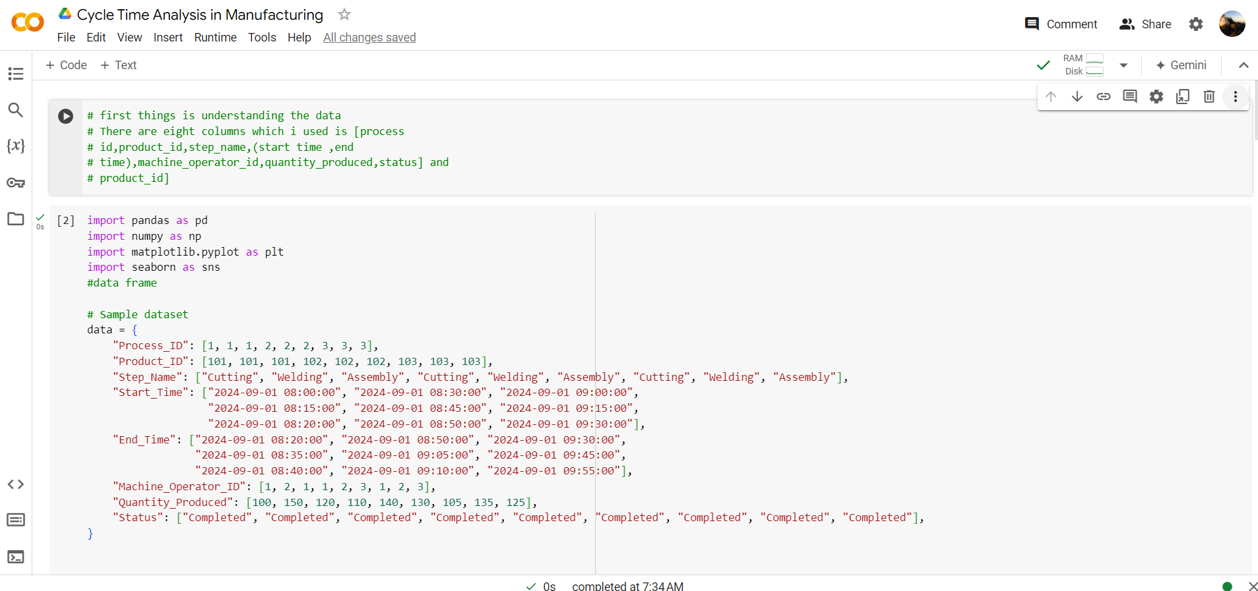

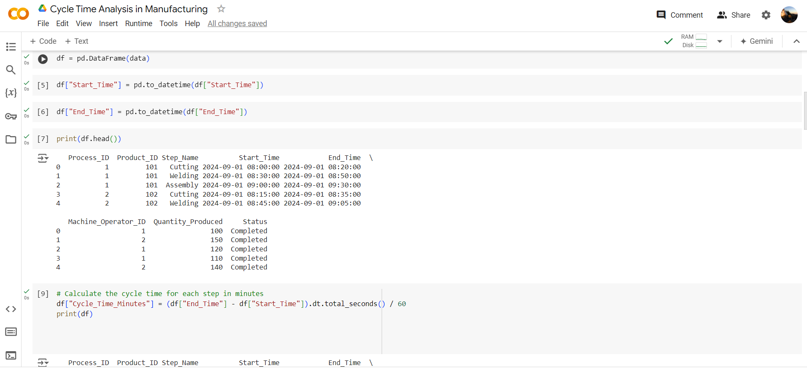

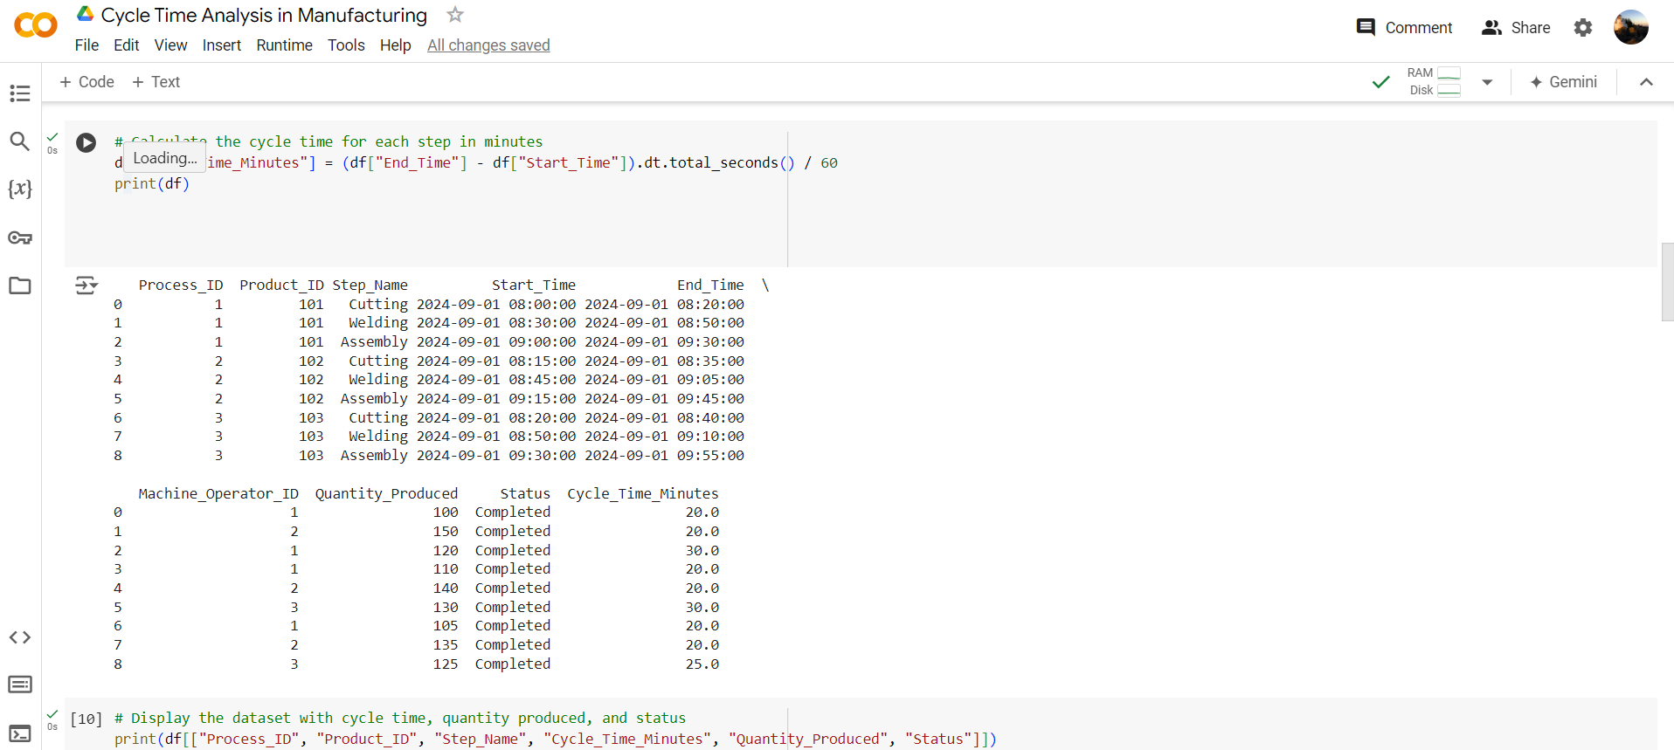

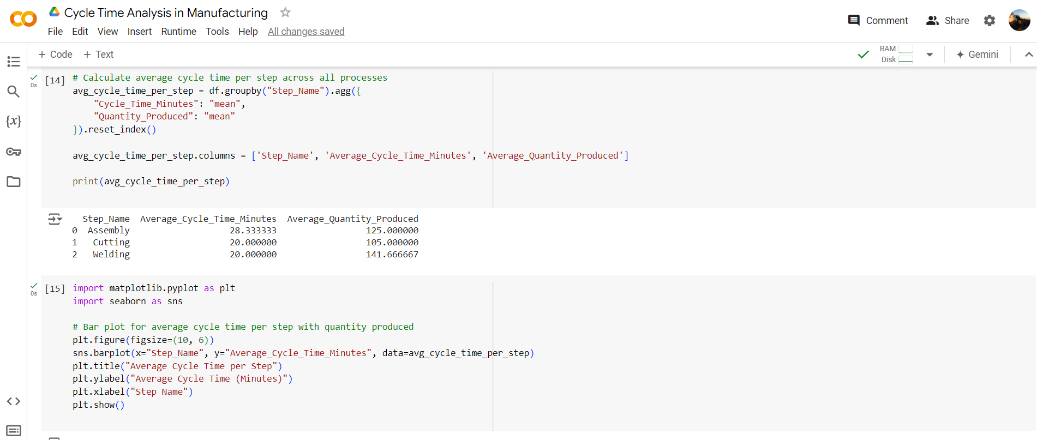

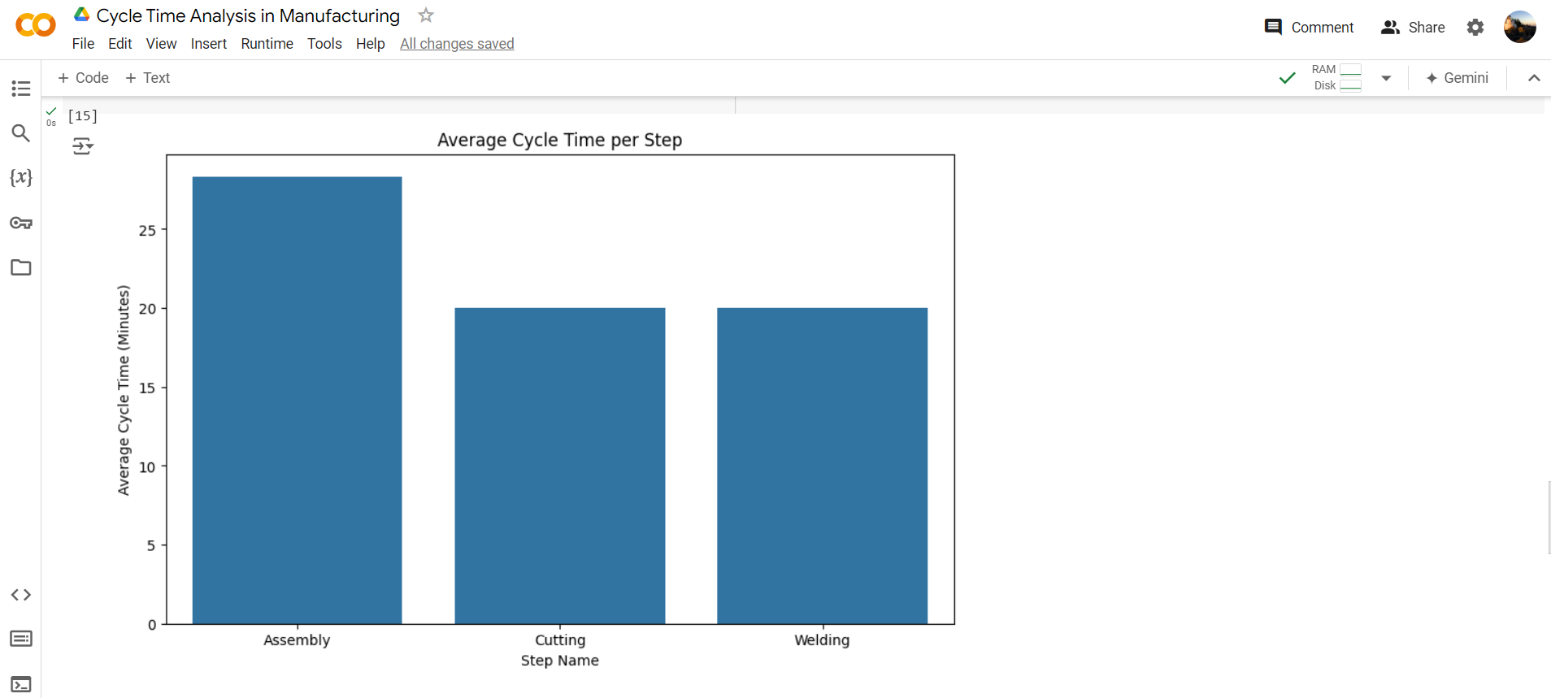

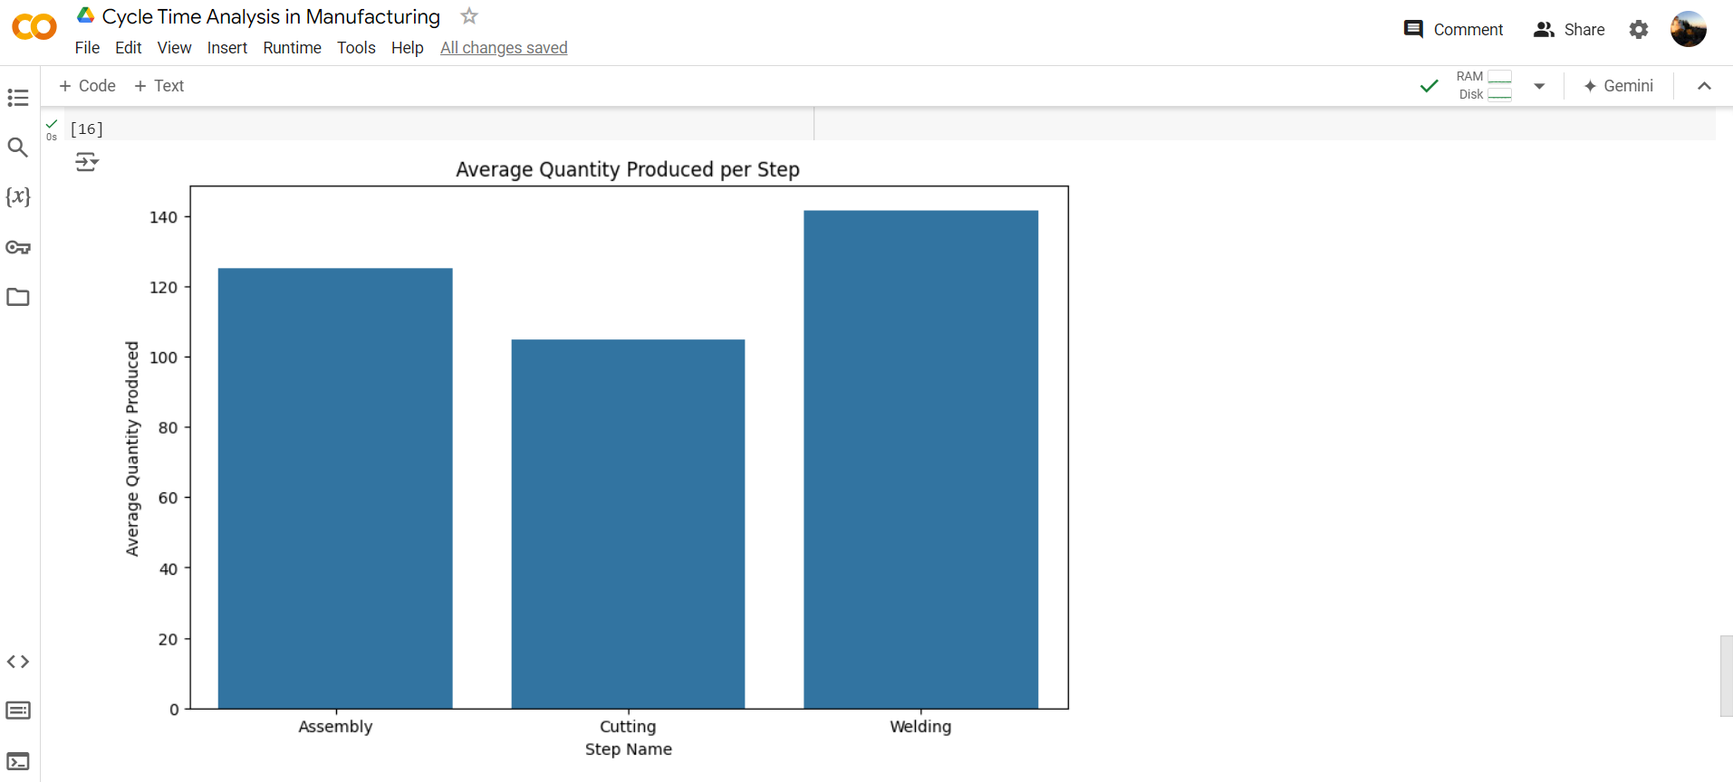

**Progress**

* **Accomplishments:** To effectively highlight and accomplish cycle time analysis in the manufacturing sector, start by clearly defining the scope and objectives of the analysis, such as reducing production delays or improving overall efficiency. Gather accurate and comprehensive data on each stage of the production process, including start and end times, to calculate precise cycle times. Use data visualization tools like Power BI or Tableau to create dashboards that highlight key metrics and identify bottlenecks in real-time. Conduct a detailed analysis to uncover patterns, such as recurring delays or variations in cycle times across different shifts or machines. Apply root cause analysis to understand the underlying issues contributing to inefficiencies, and then propose actionable solutions, such as process adjustments, equipment upgrades, or staff training. To ensure success, collaborate closely with production teams to implement these changes and continuously monitor the impact of improvements. By consistently measuring and analyzing cycle times, you can drive ongoing enhancements in production efficiency, reduce costs, and increase overall productivity.
* **Metrics:** To effectively show the metrics in cycle time analysis for the manufacturing sector, use clear and impactful data visualization techniques. Start by presenting the average cycle time across different production stages, using bar charts or line graphs to compare these times and highlight variations. Include metrics such as maximum, minimum, and median cycle times to provide a complete picture of the process's efficiency. Heat maps can be used to identify bottlenecks by showing which stages consistently have longer cycle times. Additionally, overlay cycle time data with other key performance indicators (KPIs) like equipment utilization, downtime, and throughput to offer deeper insights. Dashboards in tools like Power BI or Tableau can dynamically display these metrics, allowing stakeholders to monitor trends over time and make data-driven decisions. Ensure that the visuals are easy to interpret, with clear labels and color coding, to effectively communicate the findings and support continuous improvement efforts.

**Challenges and Solutions**

* **Challenges Faced:**

1. Inaccurate or incomplete data can lead to incorrect cycle time analysis, making it difficult to identify true bottlenecks or inefficiencies.
2. Cycle time data often comes from multiple sources, such as different machines, departments, or shifts, making it difficult to integrate and analyze.
3. Even with accurate data, pinpointing the root causes of cycle time inefficiencies can be complex due to the interplay of multiple factors.
4. Implementing changes based on cycle time analysis can face resistance from staff who are accustomed to existing processes.
5. Manufacturing environments are often dynamic, with frequent changes in product design, order volume, or equipment, making it challenging to maintain consistent cycle times.
6. Presenting cycle time data in a way that is easily understood by all stakeholders can be difficult, especially when dealing with large datasets or complex processes.

* **Solutions Implemented:**

1. Implement automated data collection systems, such as IoT sensors or machine monitoring software, to capture real-time, accurate data. Regularly audit the data for consistency and accuracy.
2. Use data integration tools that can consolidate information from various sources into a unified platform. Employ ETL (Extract, Transform, Load) processes to ensure data is clean and ready for analysis.
3. Combine cycle time analysis with other data, such as maintenance logs, workforce performance, and production schedules, to gain a holistic view. Use advanced analytics, like regression analysis or machine learning, to identify patterns and correlations.
4. Involve key stakeholders early in the analysis process, clearly communicate the benefits of proposed changes, and provide training to ensure a smooth transition.
5. Continuously monitor cycle times and update the analysis to reflect changes in the production environment. Use flexible and adaptable tools that can quickly adjust to new data inputs.
6. Use intuitive and interactive dashboards with clear visualizations. Employ a mix of charts, graphs, and heat maps to simplify complex data and make it accessible to all levels of the organization.

**Next Steps**

* **Upcoming Tasks:** To effectively face upcoming tasks in the manufacturing sector, prioritize planning and resource allocation, use data-driven insights to anticipate challenges, and maintain clear communication and flexibility to adapt to changes.
* **Goals:** To set clear goals for upcoming tasks in the manufacturing sector, start by defining specific, measurable objectives that align with overall business targets.

**Conclusion**

* **Summary:** Cycle time analysis in the manufacturing sector is a powerful tool for optimizing production processes and enhancing overall efficiency. By systematically measuring and analyzing the time taken for each stage of production, manufacturers can identify bottlenecks, reduce inefficiencies, and improve resource allocation. The insights gained from this analysis enable data-driven decisions that lead to cost reductions, higher productivity, and improved product quality. Although challenges such as data accuracy, integration, and resistance to change may arise, they can be effectively managed with the right strategies and tools. Ultimately, cycle time analysis is essential for continuous improvement, helping manufacturers remain competitive and responsive in a rapidly evolving market.
* **Acknowledgments:** Thank you all for your time and attention. Your engagement and interest in Cycle Time Analysis in the manufacturing sector are greatly appreciated. If you have any questions or need further information, please feel free to reach out. Have a great day.